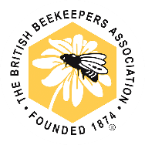

Dear

Thank you for agreeing to help us monitor for yellow-legged ‘Asian’ hornets (YLH) in the area. Members of the British Beekeepers’ Association are supporting the Department for Environment, Food and Rural Affairs (Defra) and the National Bee Unit (NBU) in their efforts to stop these insects from becoming established in the UK, following a significant increase in numbers in recent years.

What are yellow-legged ‘Asian’ hornets? Yellow-legged ‘Asian’ hornets are an invasive species of insect that are now widespread in Europe, after being accidentally introduced in France in 2004. They were first discovered here in 2016 and numbers remained steady until 2023, when 72 nests were found in 56 different locations - more than the previous six years combined. Currently we are in an ‘eradication’ phase, with the NBU leading a trapping programme through which they aim to track, trace and destroy all nests.

Why are they a problem? YLH are voracious and adaptable predators, capable of causing significant ecological damage through their predation on vital pollinators. Honey bees make up the bulk of their diet – as much as 60% - but they have also been known to feed on a number of other insects and pollinators. One colony alone can consume over 11kg of insects a year. This could have a devastating impact on a number of other species that rely on our pollinators for survival, and in turn our wider ecosystem.

What do I need to do? In order for the NBU to destroy YLH nests, we first need to know where they are. Your support in this matter is greatly appreciated and will help ease the burden on the authorities and the local beekeeping community.

PLEASE FOLLOW CAREFULLY ALL INSTRUCTIONS AND GUIDANCE THAT YOU HAVE BEEN PROVIDED WITH.

If you think you see a YLH, please report it via the Asian Hornet Watch app (available to download on iPhone and Android devices), by visiting risc.brc.ac.uk/alert.php?species=asian_hornet, or by emailing alertnonnative@ceh.ac.uk
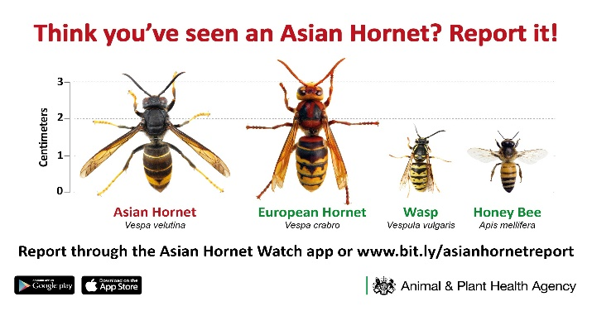
Yellow-legged ‘Asian’ hornets:
- Are smaller than the native European hornet
- Have yellow-tipped legs
- Have a dark body, with an orange band around
their lower abdomen

For more information:
Non-Native Species Secretariat website: https://www.nonnativespecies.org/non-native-species/information-portal/view/3826
National Bee Unit updates: https://www.nationalbeeunit.com/about-us/beekeeping-news/asian-hornet-2024-rolling-update/
British Beekeepers’ Association website: https://www.bbka.org.uk/Listing/Category/asian-hornet-vespa-velutina
NHS stings and bites guidance: https://www.nhs.uk/conditions/insect-bites-and-stings/

