Registering on AHA Catch (with Cumbria Asian Hornet Team)
- Go to https://catch.asianhornetalert.org.uk
- Click on the person icon on top right.
- Click on the Register now link.
- Input email.
- Input user name (full name here please as otherwise I cannot identify you within the group).
- Input password.
- Input phone no x 2 (can put mobile twice).
- Input location of trap (as a post-code) and select address from drop down menu.
- Click on roles – watcher; checker; monitor; and monitor + if you are happy to do this (look at question mark in circle for explanation of roles). Roles will say pending in red – I have to grant you any status above watcher, after which it will say granted in green.
- Tick to agree T&C and that you are not a robot, click on “register”.
- Validate your email address (see your emails – may go to spam folder).
- After validation, you should get redirected back to the webpage or if not, you can log in with email and password.
- Click on map (icon at top right is a folded map with a pin on it).
- At top righthand corner of map, click on user name.
- Click on “Edit account”.
- Add full name (again) .
- For Group – add “Cumbria AHT” (exactly as written here).
- For “Reporting to”, ignore the drop-down menu and type Clare Woowat (if North of Grasmere) or Andy Brown in the box. Drop down should then show the name you typed followed by (Cumbria AHT North) #737 or (Cumbria AHT South) #599 in yellow. Click on this and it should turn green with a tick at the end of the box (but still doesn’t go in the box for some reason!). It turns yellow after your account has finished updating.
- Click on “Update account” below the map – top right should say “Account successfully updated”.
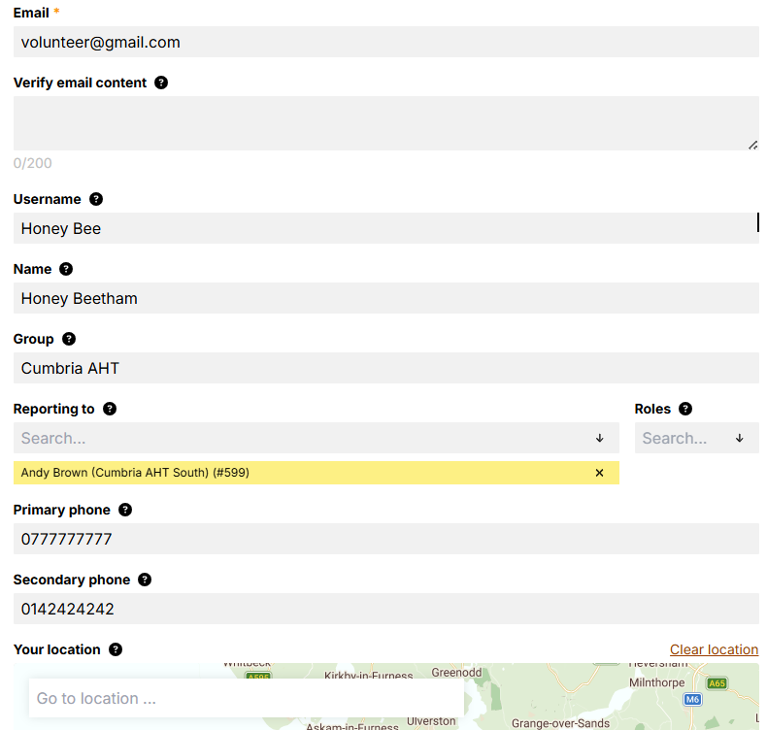

- At this point, please WhatsApp me to say you have registered as I have to grant you status above watcher for you to be able to carry out the next steps.
- See red circle at bottom right hand of screen, with a set of binoculars in it. Click on this and it opens a box for you to 1) report a YLH sighting and/or 2) create a trap record.
- Click on create a trap and tick either wick trap (an open trap that doesn’t catch anything) or trap station (i.e. a selective trap that catches YLH queens or workers).
- Add location (again seem to be only able to do this by adding a post code).
- Type a description of trap or sighting location (must add this or it won’t let you proceed).
- Can add photo.
- Click on “Activate trap” once it is out and baited.
- Click on “Submit”.
- Go to map (top right of screen, looks like folded map with a pin in it) and click on it.
- Find your trap (green icon with W or T in it) and click on it.
- A box comes up with your trap details – you can edit and click on “Update Station” if correct or can “Delete Station” if wrong and you need to re-enter your trap details.

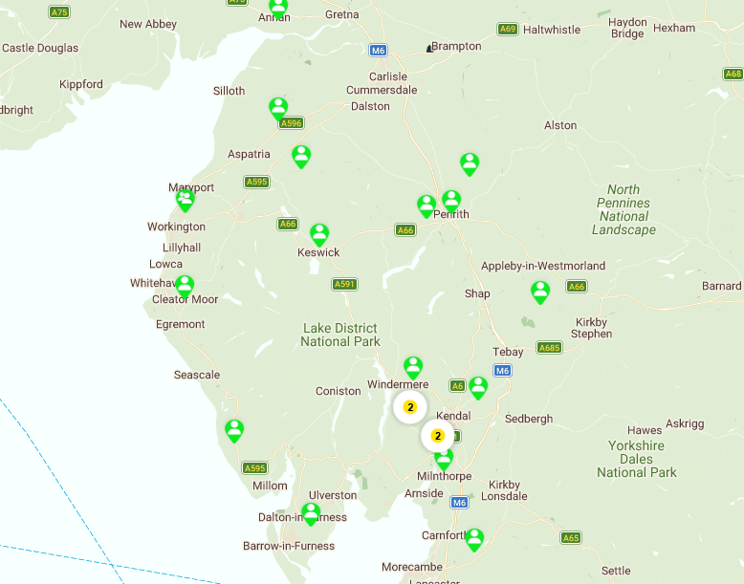

Andrew Brown / Clare Woowat
BBKA Asian Hornet Team Coordinator (Cumbria)
www.kendalbeekeepers.com/asian-hornet
cumbriaaht@gmail.com
07551 445658 / 07931 402148
WhatsApp

